Sawor

Switzerland

CompactBeam

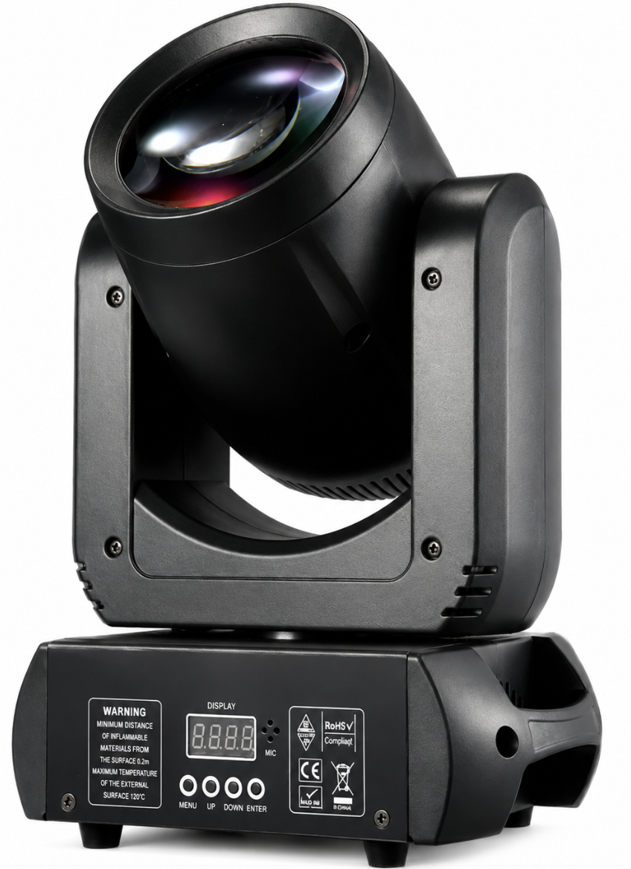

User Manual
English

Safety Information
General
This product is intended for professional use only. Improper installation, operation, or maintenance may result in electric shock, fire, burns, eye injury, or other hazards. Read and follow all safety instructions before operating the fixture.
Electric Shock Hazard
This fixture operates at hazardous voltages and can cause serious injury or death.
- Do not expose the fixture to rain, moisture, or excessive humidity.
- Disconnect power before cleaning, servicing, or moving the fixture.
- Do not operate the fixture if it is damaged or malfunctioning.
- Service must be carried out by qualified personnel only.

Fire and Burn Hazard
The light beam and fixture surfaces can become extremely hot during operation.
- Keep combustible materials away from the fixture and its beam.
- Do not focus multiple fixtures on the same area at close range.
- Maintain at least 0.2 m (8 in.) clearance from illuminated surfaces.
- Ensure that ventilation openings remain unobstructed.
- Allow the fixture to cool before handling or servicing.

Eye Hazard
This fixture produces a high-intensity light output.
- Never look directly into the light source.
- Do not view the beam through magnifying lenses, binoculars, telescopes, cameras, or similar optical devices.
- Avoid prolonged exposure to the beam at close range.

Table of Contents

Safety Information 2
Table of Contents 3
Introduction 4
Technical Specifications 5
Fixture Menu 6
Mounting 7
Effects 7
Cleaning and Maintenance 9
DMX Protocol 9

Introduction
The Sawor CompactBeam is a compact, low noise moving-head fixture powered by a high-output LED light source. Its narrow beam angle, vibrant color wheel, and prism effects allow the creation of striking aerial looks, dynamic movement, and eye-catching stage effects.
Featuring dimming, strobe functionality, and precise pan and tilt movement, the fixture delivers top performance for live events, clubs, venues, and mobile entertainment applications. Its lightweight yet durable construction makes it equally suitable for touring productions and permanent installations.
The fixture supports industry-standard DMX512 control and integrates seamlessly with professional lighting systems, providing reliable operation and flexible programming options for a wide range of lighting designs.
The fixture is supplied with this user manual, a 1.5 m (5 ft) power cable and a mounting bracket.

Technical Specifications
These specifications were measured by Sawor in Switzerland for this specific fixture.
Parameter | Specification
Fixture
Housing Color | Black
Height | 340 mm
Width | 230 mm
Depth | 150 mm
Weight | 3 kg
Cooling | Active cooling
IP Rating | IP 33 (Indoor use only)
Light Source
Light Source | 60 W COB LED
Color Temperature | 8500 K White
Optical System
Beam Angle | 2°
Illuminance | 550'000 lux @ 2m  22’000 lux @ 10m
Peak Intensity | 2’200'000 cd
Gobo Wheel | 7 + open
Color Wheel | 7 + open
Prism | 18-Facet Rotating Prism
Beam Angle (Prism) | 14°
Control & Operation
Power Supply | 220-240 V AC, 50Hz
DMX Channels | 12
Power Consumption | 80 W max.
Apparent Power | 140 VA max.
Power Switch | Yes
Built-in Microphone | Yes
Grounding (PE) | Yes
Connections
Power Input | Neutrik® PowerCON® Compatible Connector
DMX-Input | 3-Pin XLR
DMX-Output | 3-Pin XLR

Fixture Menu
This fixture is equipped with an LCD control panel that allows access to all settings and functions.
Press the MENU button to cycle through the available menu items. Use the UP and DOWN buttons to select the desired option or adjust a value. Press ENTER to confirm and save the selected setting.
Example: To set the DMX address, press MENU until the DMX Address screen is displayed. Use the UP and DOWN buttons to select the desired address, then press ENTER to save the setting.
Function | Menu Item | Values | Description
DMX Adress | 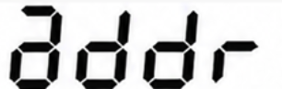 | 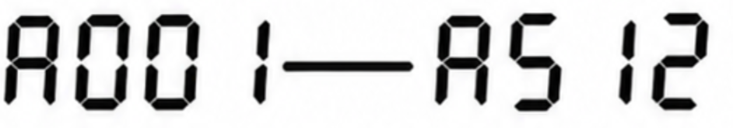 | Sets the fixture's DMX start address.
Channel Mode | 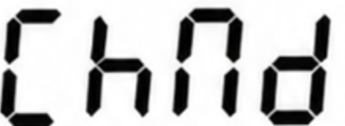 | 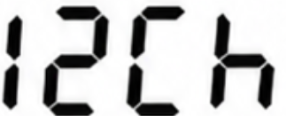 | Fixed 12-channel DMX mode.
Operating Mode | 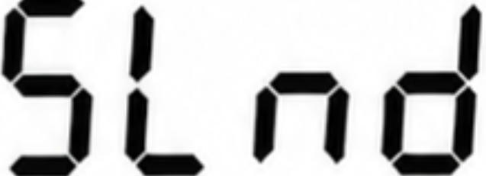 | 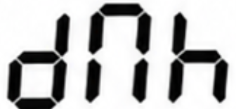 | DMX control mode.
Operating Mode |  | 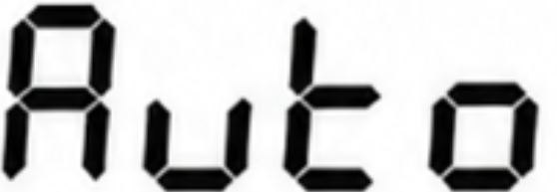 | Automatic show mode.
Operating Mode |  | 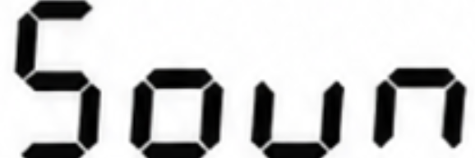 | Sound-active mode.
Pan Reverse | 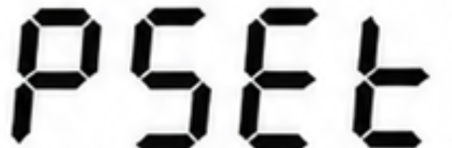 | 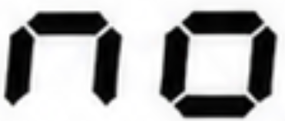 | Reverses pan movement direction.
Pan Reverse |  | 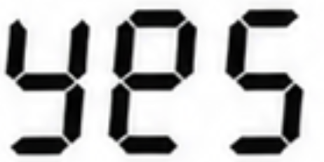 | Reverses pan movement direction.
Tilt Reverse | 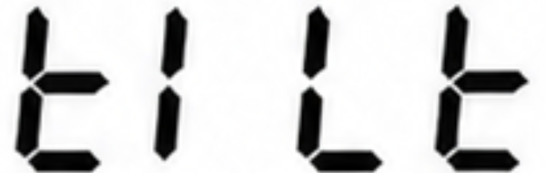 |  | Reverses tilt movement direction.
Sound Sensitivity | 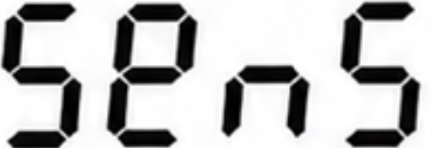 | 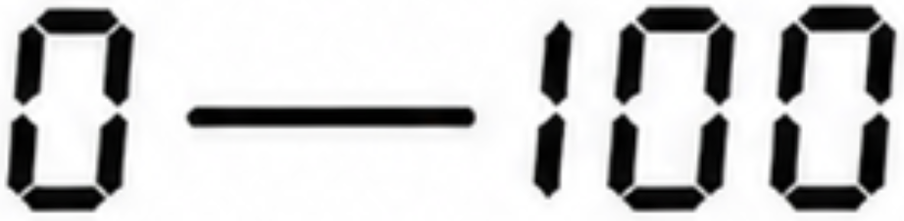 | Microphone sensitivity from low to high.
Display Backlight | 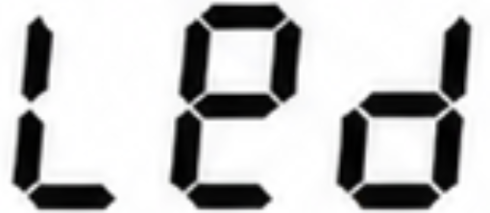 |  | Keeps display illuminated.
Display Backlight |  | 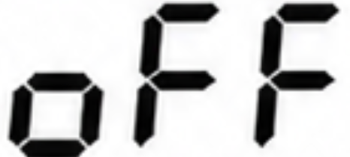 | Keeps display illuminated.
Display Invert | 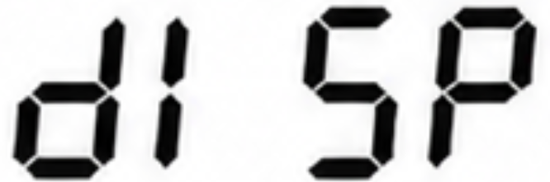 |  | Flips the display for inverted installation.
Internal Fixture Temperature | 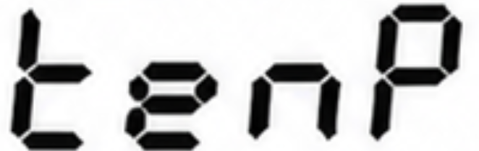 | - | Displays the internal fixture temperature in ° C.
Software Version | 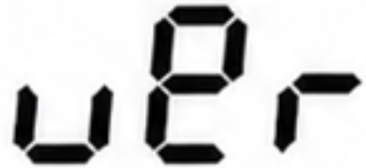 | - | Displays installed firmware version.
Factory Reset | 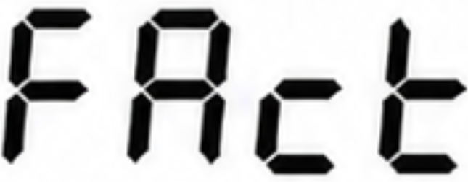 |  | Restores factory default settings.

Mounting
The fixture is supplied with a mounting bracket. The bracket can be attached to the rear of the fixture using the pre-installed screws. Once installed, a suitable clamp may be fixed to the bracket for mounting on truss systems, lighting stands, or other supporting structures.
When the fixture is suspended above ground level, an appropriate safety cable must always be used in addition to the primary mounting method. Attach the safety cable around one of the fixture handles and ensure that it is rated for the weight of the fixture and complies with local safety regulations.
Before each use, verify that all screws, clamps, and safety devices are securely fastened and free from damage.

Effects
Pan & Tilt
The fixture’s moving head can be panned through 540° and tilted through 180° using coarse or fine control channels.
Gobos
This Fixture incorporates a 7-pattern gobo wheel.
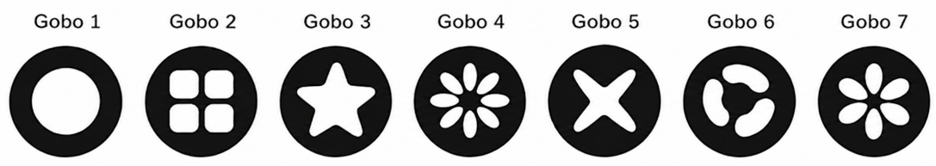
Any gobo can be projected statically. Gobos can be shaken, and the gobo wheel can be rotated clockwise or counter-clockwise.
Prism
The fixture incorporates a prism that can be inserted into the beam to give split beam effects. The prism can be rotated clockwise or counter-clockwise.
Strobe
This Fixtures provides strobe effects of variable speeds up to 25 hz.
Electronic dimming
The LED light source can be dimmed from 0-100%. It can be switched on or off at any time.
Color wheel
The fixture incorporates a color wheel, with seven colors plus open. Individual color slots can be selected, or the wheel can be rotated continuously.

Cleaning and Maintenance
Regular cleaning is essential to maintain light output and ensure reliable operation. Dust, smoke fluid residue, and other airborne particles can reduce performance and cause overheating.
Cleaning intervals depend on the operating environment. Fixtures used in dusty conditions or near smoke and fog machines may require more frequent cleaning.
To clean the fixture:
- Disconnect the fixture from power and allow it to cool completely.
- Remove dust from the housing and ventilation openings using a soft brush, vacuum cleaner, or low-pressure compressed air.
- Clean lenses and exterior surfaces with a soft, lint-free cloth lightly dampened with mild detergent or glass cleaner.
- Dry all surfaces thoroughly before reconnecting power.
Important: Do not use solvents, abrasive cleaners, or excessive force, as these may damage the fixture. Damage resulting from inadequate maintenance is not covered by warranty.

DMX Protocol
Chan. | Value |  | Function
1 | 0-255 |  | Pan 0°-540°
2 | 0-255 |  | Pan (fine control)
3 | 0-255 |  | Tilt 0°-180°
4 | 0-255 |  | Tilt (fine control)
5 | 0-255 |  | Pan/tilt speed, fast-slow
6 | 0-255 |  | Dimmer 0-100%
7 | Strobe
7 | 0-15 |  | Off
7 | 16-255 |  | Strobe, slow-fast
8 | Color Wheel
8 | 0-15 |  | Open/White
8 | 16-31 |  | Red
8 | 32-47 |  | Yellow
8 | 48-63 |  | Green
8 | 64-79 |  | Orange
8 | 80-95 |  | Blue
8 | 96-111 |  | Magenta
8 | 112-127 |  | Cyan
8 | 128-255 |  | Clockwise, slow-fast
9 | Gobo Wheel
9 | 0-7 |  | Open
9 | 8-15 |  | Gobo 1
9 | 16-23 |  | Gobo 2
9 | 24-31 |  | Gobo 3
9 | 32-39 |  | Gobo 4
9 | 40-47 |  | Gobo 5
9 | 48-55 |  | Gobo 6
9 | 56-63 |  | Gobo 7
9 | 64-71 |  | Gobo 1 Shake, slow-fast
9 | 72-79 |  | Gobo 2 Shake, slow-fast
9 | 80-87 |  | Gobo 3 Shake, slow-fast
9 | 88-95 |  | Gobo 4 Shake, slow-fast
9 | 96-103 |  | Gobo 5 Shake, slow-fast
9 | 104-111 |  | Gobo 6 Shake, slow-fast
9 | 112-119 |  | Gobo 7 Shake, slow-fast
9 | 128-255 |  | Clockwise, slow-fast
10 | Prism (18-Facet)
10 | 0-8 |  | Prism Off
10 | 8-127 |  | Prism On
10 | 128-255 |  | Prism Rotation, slow-fast
11 | Automatic Mode / Sound Control Mode
11 | 0-50 |  | Automatic Mode Off
11 | 50-100 |  | Automatic Mode, fast
11 | 101-200 |  | Automatic Mode, slow
11 | 201-255 |  | Sound Control Mode
12 | Reset
 | 0-249 | No Effect
 | 250-255 | Reset after 3s

Specifications are subject to change without notice. All values were measured under laboratory conditions and may vary depending on operating environment and manufacturing tolerances.

